

John Boyce is a Full Member of The Association of British Investigators (Membership No F/2150)

[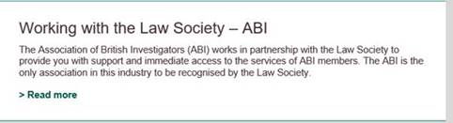](https://www.lawsociety.org.uk/support-services/membership-extra/business-services/abi/)

JJ Collect Limited is registered under the Data Protection Act Reg. No. Z2987808